

JOURNAL OF APPLIED SCIENCE
AND
ENGINEERING MATERIALS

Su İçinde Yağ Emülsiyonunda Yerinde Polimerizasyonla Esans Mikrokapsülasyonu: Uzun Süreli Dispersiyon Kararlılığı İçin Katyonik Yüzey Fonksiyonlandırması
Fragrance Microencapsulation by Oil-in-Water in Situ Polymerization: Cationic Surface Functionalization for Long-Term Dispersion Stability
Bleda Can Sadikogullari
Department of Chemistry, Faculty of Science and Letter, İstanbul Technical University, https://ror.org/059636586, Turkey sadikogullari@itu.edu.tr, https://orcid.org/0000-0003-1633-2993
Harun Taşdemir
Parkim Parfume Plastic & Chemical Ltd., Turkey, harun@parkimgroup.com
Özge Kavas
Parkim Parfume Plastic & Chemical Ltd., Turkey, ozge.kavas@parkimgroup.com
Yesim Cat
Parkim Parfume Plastic & Chemical Ltd., Turkey, yesim@parkimgroup.com
Akın Sağırlı
Department of Chemistry, Faculty ofArts & Sciences, Bolu Abant Izzet Baysal University, https://ror.org/01x1kqx83, Turkey, sagirli_a@ibu.edu.tr, https://orcid.org/0000-0003-0759-334X
Sonay Gurer
Parkim Parfume Plastic & Chemical Ltd., Turkey, sonay@parkimgroup.com
Bunyamin Karagoz*
Department of Chemistry, Faculty of Science and Letter, İstanbul Technical University, https://ror.org/059636586, Turkey, karagozb@itu.edu.tr, https://orcid.org/0000-0003-1191-218X (corresponding author)

Makale Türü:
Araştırma Makalesi

Geliş Tarihi:
Revizyon Tarihi:

Kabul Tarihi:

DOI:

Bu makaleye atıf vermek için:

Özet
Günümüzde ticari olarak temin edilebilen birçok kumaş yumuşatıcı, uzun depolama sürelerinden sonra bile tüketicilere kalıcı koku salımı sağlamak amacıyla kapsüllenmiş esanslar içermektedir. Çeşitli teknikler arasında yerinde polimerizasyon, esansların mikrokapsüllenmesi için düşük maliyetli ve kolaylıkla ölçeklenebilir bir yöntem sunması nedeniyle en yaygın kullanılan yöntemlerden biridir. Bu bağlamda, temel performans gereklilikleri genel olarak esansın korunması ve uzun süreli salımının sağlanmasıdır. Bununla birlikte, birçok ticari uygulamada kapsül sistemlerinin kullanıma hazır kapsül dispersiyonları hâlinde sunulması nedeniyle, kumaş yumuşatıcı formülasyonuna eklenmeden önce mikrokapsüllerin dispersiyon kararlılığı da bu temel gereklilikler kadar önemlidir. Bu kapsamda, çalışmada metanol ile modifiye edilmiş melamin-formaldehit reçinesi (MMF) kullanılarak esans yüklü mikrokapsüllerin hazırlanması ve uzun süreli dispersiyon kararlılığının iyileştirilmesi amacıyla kürleme sonrasında glisidil trimetilamonyum klorür ile modifiye edilmesi araştırılmıştır. Optik mikroskopi ve SEM analizleri, çoğunlukla küresel morfolojiye ve 20–30 µm aralığında boyutlara sahip mikrokapsüllerin elde edildiğini göstermiş; termal olarak dayanıklı MMF kabuğunun varlığını desteklemek amacıyla TGA analizi gerçekleştirilmiştir. Glisidil trimetilamonyum klorür ile yapılan modifikasyonun kapsül performansını olumsuz yönde değiştirmediği, buna karşılık uzun süreli dispersiyon kararlılığı sağladığı ve yıkama sonrasında kumaş üzerindeki kapsül birikimi ile tutunmasını iyileştirmiş olabileceği belirlenmiştir.
Anahtar Kelimeler: Katyonik fonksiyonlandırma; Kolloidal kararlılık; Esans mikrokapsülasyonu.
Abstract
Today, many commercially available fabric softeners contain encapsulated fragrances to provide consumers with prolonged release of the fragrance even after extended storage periods. Among various techniques, in situ polymerization is one of the most common methods, as it offers a cost-effective and easily scalable method for fragrance encapsulation. In that regard, the primary performance requirements are generally fragrance protection and prolonged release. On the other hand, the dispersion stability of the microcapsules prior to addition to a fabric softener formulation is as important as the primary requirements since in many commercial applications, capsule systems are supplied as ready-to-use capsule dispersions. In this context, this study investigates the preparation of fragrance-loaded microcapsules using methanol-modified melamine-formaldehyde resin (MMF) and their post-curing modification with glycidyl trimethylammonium chloride to improve long-term dispersion stability. Optical microscopy and SEM analyses revealed predominantly spherical microcapsules with sizes in the 20-30 µm range, and TGA was conducted to support the presence of the thermally resistant MMF shell. It was found that modification with glycidyl trimethylammonium chloride did not alter the performance but provided long-term dispersion stability and suggested improved deposition and retention on the fabric after laundering.
Keywords: Cationic functionalization, Colloidal stability, Fragrance microencapsulation.

- Introduction
Fragrance materials are widely used in consumer products, such as detergents, fabric softeners, household cleaners, shampoos, shower gels, etc., to provide a pleasant and long-lasting odour (Podgornik et al., 2021). However, their practical performance is often limited by their volatile and chemically sensitive nature, as many fragrance components can readily oxidize or degrade, such as essential oils and unsaturated compounds (Podgornik et al., 2021). Additionally, in commercial household and personal care applications, maintaining a consistent fragrance character across different products is of utmost importance. For all these reasons, encapsulation of fragrance materials is done not only to protect the fragrance components from external factors such as air, light, heat, etc., but also to improve compatibility with different formulations. Among several applications, fabric softeners represent an important application area, as not only protection of fragrance material and improved compatibility in softener formulations needed, but also retention on fabric and prolonged release should be provided as the performance generally associated with longevity (Podgornik et al., 2021; Lamboley et al., 2023; Pithanthanakul et al., 2021).
For that purpose, two distinct methodologies are often used: (i) encapsulation of the fragrances with polymeric material, which depends on the triggered release of fragrance upon mechanical stress, or (ii) use of pro-fragrances, which relies on the controlled degradation of fragrance under mild conditions like everyday sunlight exposure. In this context, fragrance encapsulation is more widely applied in consumer products, as it can be directly used with complex commercial fragrance blends, whereas pro-fragrance systems generally require specific molecular design, which limits their practical applicability (Lamboley et al., 2023; Zaitoon et al., 2021; Hermann, 2007; Murph, 2015).
Both in the literature and in many industrial applications, prepolymers are widely used for fragrance microencapsulation, including urea-formaldehyde (UF), melamine-formaldehyde (MF), polyurethane, and polyurea-based systems (Podgornik et al., 2021; Su et al., 2004; Su et al., 2012; Fei et al., 2015; Topbas et al., 2020). Although conventional polymeric microcapsules are generally designed to protect fragrance components for shelf life and prolonged release, many of them do not provide additional advantages for capsule deposition and retention on the fabric surfaces, which is directly related to the performance of the consumer product, as quality and performance are often associated with the longevity of the fragrance.
In this study, to improve deposition on fabric surfaces, cationic functionality was introduced onto the capsule shell after oil-in-water (O/W) fragrance encapsulation, which was carried out by in situ polymerization of methanol modified melamine-formaldehyde (MMF) resin as the shell-forming material.
- Conceptual Framework
Microencapsulation of target materials can be done with several methods but can be classified to three main categories, (i) chemical methods, which includes in situ polymerization, interfacial polymerization, and photopolymerization, physicochemical methods which basically stands for coacervation techniques and lastly (iii) physical methods that consist of spray drying and solvent evaporation, that rely on the removal of a carrier phase to obtain encapsulated materials (Podgornik et al., 2021; Jamekhorshid et al., 2014; Massella et al., 2019; Xu et al., 2021).

In this context, fragrance microcapsules for fabric-softener applications are commonly produced by in situ or interfacial polymerization, as these methods provide rapid, cost-effective, scalable, and reproducible production routes suitable for commercial use (Murph, 2015). Moreover, the capsule shell must retain its structural integrity not only during product formulation, storage, and transportation, but also after deposition onto the textile, including during drying, folding, wardrobe storage, and routine handling, thereby requiring a dense and sufficiently crosslinked polymeric shell to minimize diffusion and leakage and maximize the retention of encapsulated fragrance deposition on the fabric following laundering, ironing and subsequent storage (Murph, 2015).

Within this context, the present study is based on the chemical microencapsulation of two different fragrance mixtures through the in situ polymerization of methanol-modified melamine-formaldehyde resin in an oil-in-water emulsion system. To this end, all fragrance systems were prepared using the same encapsulation procedure, and the resulting microcapsule shells were subsequently subjected to cationic functionalization to enhance their affinity toward textile surfaces as well as improve the colloidal stability of the final formulation. Selected fragrance mixture was utilized for the individual analytical evaluations, including encapsulation yield by gravimetric analysis, encapsulation efficiency with UV-Vis spectroscopy, morphology with optical microscopy and scanning electron microscopy (SEM), and thermal characteristics with thermogravimetric analysis (TGA), while performances are evaluated with olfactory scoring.
- Material and Methods
Two different fragrance mixtures were encapsulated through in situ polymerization of a methanol-modified melamine-formaldehyde prepolymer in an oil-in-water emulsion system using a modified procedure based on previously reported methods (Su et al., 2004; Su et al., 2012; Fei et al., 2015; Sumiga et al., 2011). The encapsulation performance of the formulations was evaluated by determining the encapsulation yield and efficiency, whereas the morphology and thermal characteristics of the microcapsules were examined using scanning electron microscopy and thermogravimetric analysis, respectively. The performance of the developed systems on textile substrates was further assessed through post-laundering olfactory evaluations. Each fragrance mixture was selected for specific analytical evaluations.
  - Materials and Instrumentation
Materials.
Materials. The chemicals used in the encapsulation procedure were styrene-maleic anhydride copolymer (SMA, M_{n} = 520 g/mol, supplied by Solenis), methanol-modified melamine-formaldehyde resin (ALMUN 70, supplied by Gentaş Chemicals), sodium hydroxide (≥97.0%, ACS reagent), hydrochloric acid (37 wt.%, ACS reagent), and glycidyl trimethylammonium chloride (≥90%, technical grade), supplied by Sigma-Aldrich, dye colourant used in the study was supplied by Sensient. The commercial fragrance mixtures PINK Capsule ENC Last, and GREEN CAPSULE ENC Last were supplied by Parkim Fragrance House. Deionized water was used throughout the experiments, and all materials were used as received without further purification.
Instrumentation. Microcapsule synthesis was performed in a jacketed glass reactor equipped with an overhead mechanical stirrer and connected to a temperature-controlled circulating bath. The pH of the reaction mixtures was monitored using a calibrated pH meter. Optical microscopy images were recorded with marka model tip optical microscope. For SEM imaging a JEOL JSM-5600 scanning electron microscope is used after drying and coating with a thin gold-palladium layer under high vacuum. Thermogravimetric analysis was conducted using a Mettler Toledo TGA/SDTA851e instrument from room temperature to 700 °C at a heating rate of 10 °C/min under a nitrogen atmosphere. UV-vis measurements were taken in a T80 + UV/vis spectrophotometer with quartz cuvettes in the 190-1100 nm range (light path: 10 mm) after phase separation via centrifugation.
  - Experimental Procedure
    - Preparation of Fragrance-Loaded Encapsulate
Fragrance encapsulation was carried out by in situ polymerization in an oil-in-water (O/W) emulsion using an overall water-to-fragrance mass ratio of 3:1, with the procedure initiated by adding SMA (5.0 g, 5% w/w relative to the fragrance) and NaOH (1.5 g, 30% w/w relative to SMA) to 200 g of deionized water in a jacketed glass reactor and stirring the mixture at 200 rpm and 80 °C until a clear solution was obtained and cooled down to room temperature after which selected fragrance mixture (100 g) directly added and the system was stirred at 500 rpm until homogeneous oil-in-water emulsion was formed followed by addition of methanol-modified melamine-formaldehyde prepolymer (20 g, 15% w/w relative to fragrance) in water (95 g) and firstly stirred at room temperature for 1 h to allow the prepolymer to distribute within the continuous phase and accumulate at the fragrance-water interface. The initial pH was measured and recorded, and the pH of the mixture was then adjusted to approximately 5.5 using 1 M HCl. The reactor was set to 90 °C, and the mixture was heated under continuous stirring for an additional 2 hours. After the curing of the pre-polymer was completed, the reactor was set to room temperature, and glycidyl trimethyl ammonium chloride (5 mL, 5% v/w relative to the fragrance) was added to the reaction mixture and stirred continuously until the reaction mixture was cooled down to the set temperature. The pH of the resulting microcapsule was checked and adjusted to 7 with dilute NaOH to end curing and minimize the presence of unreacted formaldehyde, and finally diluted with selected fragrance (10 g, 10% w/w) to complete the resulting mixture that is ready to use in commercial fabric softener essence.
    - Preparation of Fabric Softener
- Results and Discussion
In the context of the present study, the performance of synthesized fragrance encapsulates was evaluated by their physicochemical characteristics and their olfactory behaviour on textiles. On the other hand, as the primary purpose of glycidyl trimethylammonium chloride functionalization was to improve the colloidal stability of the microcapsules within the ready-to-use fabric-softener formulation, prepared samples were collected and visually monitored immediately after preparation and after 1 day, 1 week, 1 month, and 6 months of storage (Figure 1). During this storage period functionalized microcapsules remained uniformly dispersed, whereas unmodified capsules settled a few hours after preparation. This enhanced stability is attributed to the positive surface charge introduced by the quaternary ammonium groups, which increased electrostatic repulsion between neighbouring microcapsules and thereby reduced their tendency to settle, and eliminated the dependence on additional suspension-stabilizing additives. The proposed mechanism for the encapsulation reaction and underlying this difference in dispersion behaviour is schematically illustrated in Scheme 1.
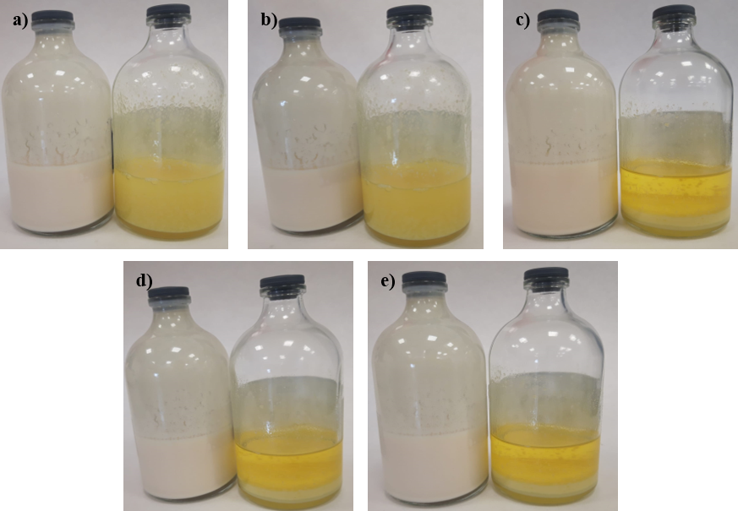
Figure 1. Ready-to-use formulations for Pink Capsule ENC Last (a) immediately after preparation, (b) 1 hour after preparation, (c) 1 week after preparation, (d) 1 month after preparation, (e) six months after preparation (left with glycidyl trimethyl ammonium chloride, right with no additive).
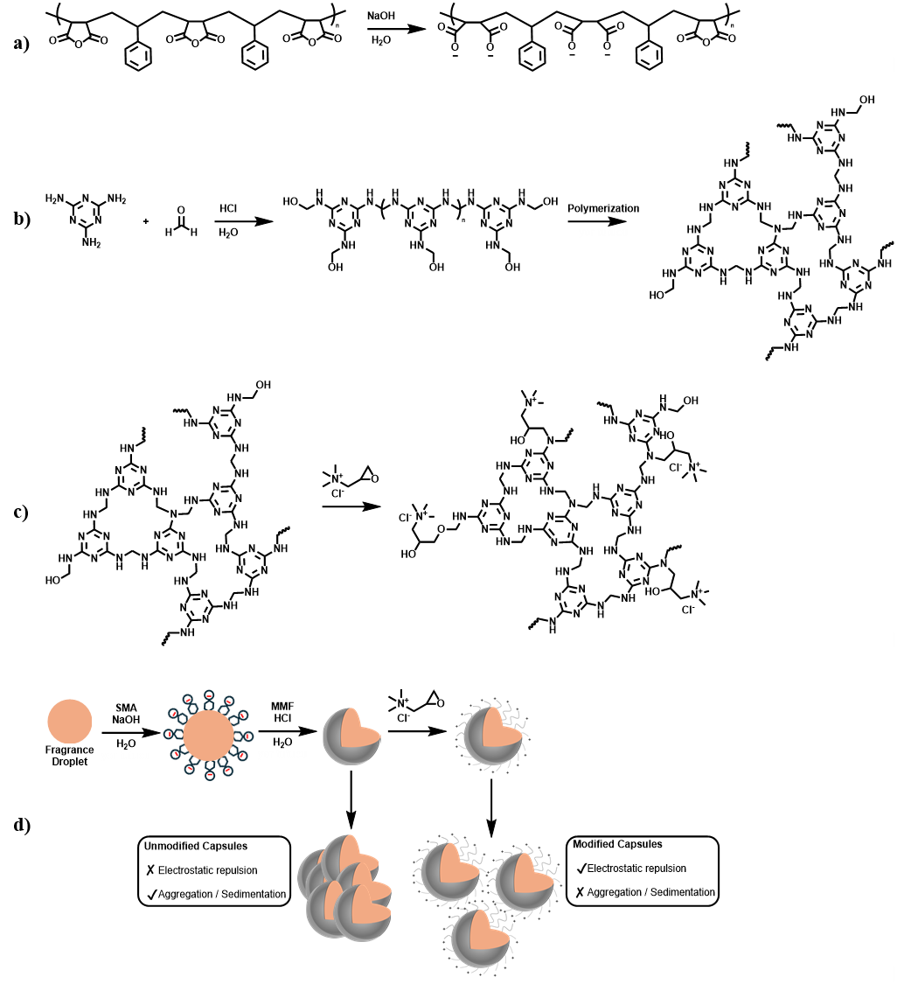
Scheme 1. Schematic overview of the structural representation of styrene-maleic anhydride copolymer before and after hydrolysis (a), in situ polymerization of MMF (b), post-curing cationic surface functionalization of the microcapsules with glycidyl trimethylammonium chloride (c), proposed influence of surface functionalization on dispersion behaviour (d).
In the context of the study to ensure capsulation, optical microscopy images were recorded at several stages of the reaction during the encapsulation process, and are shown in Figure 2. According to the presented images, spherical and morphologically stable microcapsules were obtained after 2 hours of reaction with no apparent coalescence. On the other hand, limited premixing conditions resulting from the absence of a high-shear emulsification device led to a relatively broad particle-size distribution, nevertheless, microcapsules with an average diameter of 20-40 µm were obtained, which fall within the range accepted for commercial fabric-softener applications (Murph, 2015). Also, the addition of glycidyl trimethylammonium chloride as a cationic agent after curing does not change the particle size.
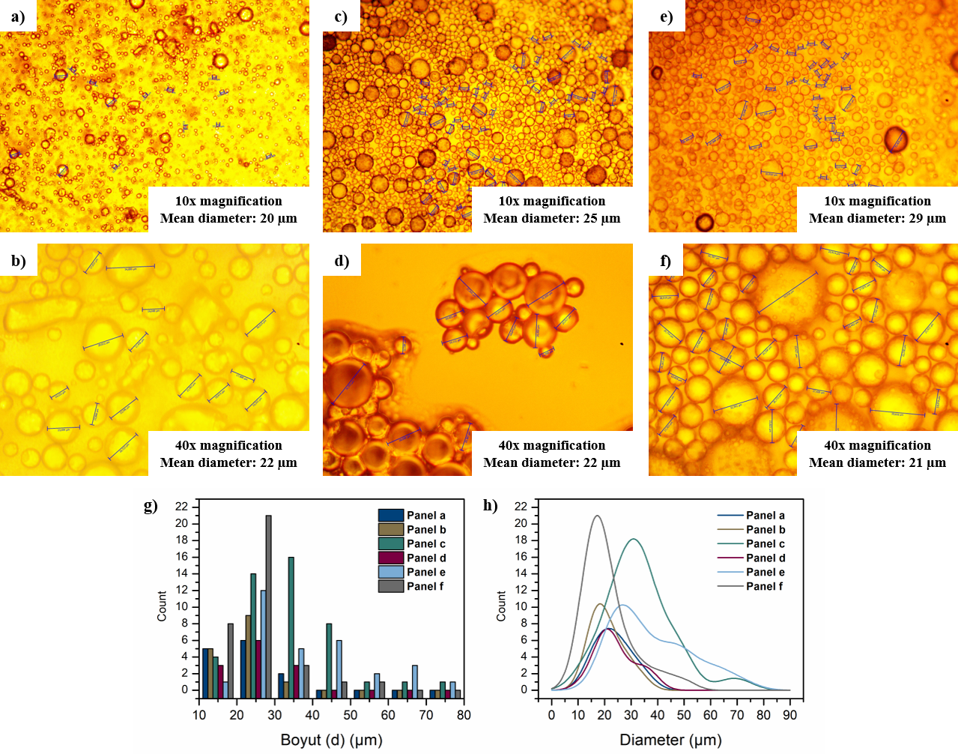
Figure 2. Optical microscopy images of fragrance-loaded microcapsules (Pink Capsule ENC Last) recorded after 30 min of reaction (a), (b), after 2 h of curing and before the addition of glycidyl trimethylammonium chloride (c), (d), after glycidyl trimethylammonium chloride addition and cooling to room temperature (e),(f), and particle-size histograms and distribution curve (g), (h). (Mean diameters were calculated from the particles measured in the corresponding images, smoothed curve was obtained with the Gaussian Kernel Method and derived from the same datasets).
To further verify the capsule structure and morphology, SEM images are also provided (Figure 3). In the light of images, predominantly spherical microcapsules are observed, which support the successful deposition and curing of the melamine-formaldehyde prepolymer around the fragrance droplets. Parallel to the optical microscopy images, a relatively broad particle-size distribution is also seen in the SEM images, as well as continuous film-like residue, which may be attributed to the limited premixing conditions that cause free MMF polymer in the continuous phase of the encapsulation process. Importantly, treatment with glycidyl trimethylammonium chloride do not cause any morphological changes in the obtained fragrance-loaded capsules.

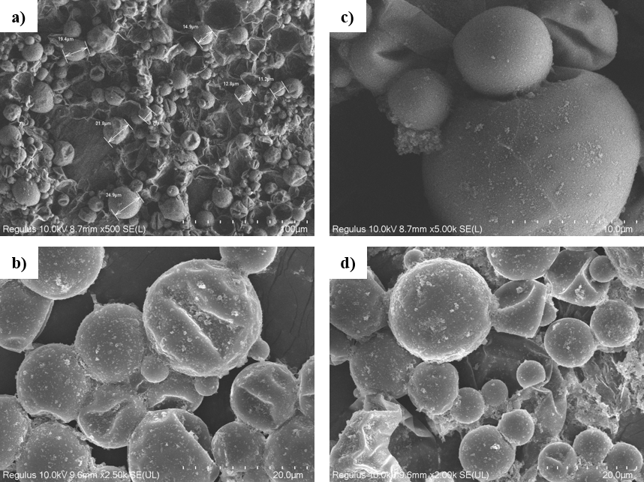
Figure 3. SEM images of fragrance-loaded (Pink Capsule ENC Last) microcapsules obtained at 500× magnification (a), 2500×magnification (b), 5000× magnification (c), 2000× magnification before treatment (d).
Overall, the SEM observations were consistent with the optical microscopy results, and both confirmed successful capsule formation. To further support the successful formation of the microcapsules and evaluate the thermal behaviour of the encapsulated fragrance systems, thermogravimetric analysis (TGA) was performed, and the resulting thermograms are presented in Figure 4.
Figure 4. TGA diagrams.
According to the obtained thermograms, the fragrance mixture (Pink Capsule ENC Last), used as the core material, exhibited a rapid weight loss starting at approximately 60 °C, and continued until 200 °C resulting in a 90% weight loss and almost complete volatilization occurring at approximately 213 °C. The MMF resin, used as the shell material in the procedure, showed three weight loss stages including an initial loss below approximately 120 °C, a gradual degradation stage between approximately 120 and 300 °C, and a more pronounced mass-loss step at around 400 °C, followed by a residual mass of approximately 10-12% at 700 °C. As the encapsulated samples were analysed directly as aqueous dispersions, a major weight-loss was observed at around 100 °C in both capsule dispersions and was primarily attributed to water evaporation. Although according to the gravimetrically determined solid content, the initial weight-loss was expected to be approximately 68%, the thermogram showed nearly 80% weight loss, which may be attributed to the added free fragrance, fragrance present on the capsule surface (Yun et al., 2021; Jafari et al., 2008), and volatile fragrance components gradually diffusing through the polymeric shell. The unmodified capsules showed a plateau between 110 °C and 300 °C, followed by a second mass-loss stage at approximately 300-350 °C, supporting the presence of a thermally resistant MMF-based shell. Unlike the unmodified capsules, the modified capsules did not exhibit a plateau but instead showed a gradual mass decrease between approximately 95 and 210 °C, followed by a second broad weight-loss extending to approximately 320 °C. This change in thermal behaviour may be attributed to the use of glycidyl trimethylammonium chloride, which introduces hydrophilic quaternary ammonium groups onto the capsule surfaces, causing a gradual weight-loss due to the presence and subsequent loss of bound water on the outer surface of the capsule shell. However, this change in thermal behaviour does not necessarily indicate reduced capsule performance.
After the formation of the microcapsules had been supported by optical microscopy, SEM, and TGA analyses, the encapsulation process was further evaluated in terms of solid yield and encapsulation efficiency using gravimetric and UV-Vis spectrophotometric methods, respectively. To determine the solid yield, a 10.0 g aliquot was collected from the final microcapsule dispersion of Green Capsule ENC Last before the addition of free fragrance and air-dried at room temperature in the dark until a constant mass was obtained. The remaining dry residue was weighed directly, and the solid yield was calculated relative to the initial mass of the aliquot. According to the measured masses, the calculated solid contents range from 24.4% to 34.2% by weight. To determine the encapsulation efficiency, the same procedure was followed, with the only modification being the composition of the fragrance phase, which consisted of 99.0 g of the Green Capsule ENC Last fragrance mixture and 1.0 g of an oil-soluble dye employed as a tracer. To this end, the dye was completely dissolved in the corresponding fragrance mixture, and a calibration curve was constructed at the dye’s maximum absorption wavelength (Figure 5). Aliquots were collected in three separate stages (i) initial fragrance and dye mixture to determine initial concentration (the collected sample was measured directly) (ii) after addition of prepolymer resin to estimate the amount transferred into the aqueous phase, and (iii) after completion of the curing process to quantify the dye remaining in the non-encapsulated oil phase. At each sampling stage except the first one, the aliquot was centrifuged to separate the oil phases, which were collected and analysed by UV-Vis spectrophotometry at the predetermined wavelength, and in each step, samples were taken as duplicates. The theoretical initial dye concentration was 10.10 mg/g, and according to the measurements, it was determined to be 10.8 ± 2.1 mg/g, which demonstrates sufficient agreement. Following the determination of the initial concentration, the reaction was carried out to the end of the emulsion step, which corresponds to 1 hour of mixing after the addition of the MMF resin. After centrifuging the samples, the separated oil phases were analysed by UV-Vis spectrophotometry, and a decrease in dye concentration was observed, which is accepted as the amount transferred to the aqueous phase during emulsification. According to the obtained spectra, the dye concentration remaining in the oil phases was determined as 7.09 mg/g ± 0.64 mg/g, indicating 33.6% ± 7.2% of the dye transferred into the aqueous phase during emulsification. Lastly, after completion of the curing process, unfortunately, not only did centrifugation fail to produce a visually distinguishable free-oil layer, but the collected supernatant also exhibited an absorbance response close to the baseline, thus no quantitative evaluation can be done; nevertheless, both observations indicated that residual non-encapsulated fragrance tracer remained after curing was negligibly low, thus qualitatively showing high encapsulation efficiency.

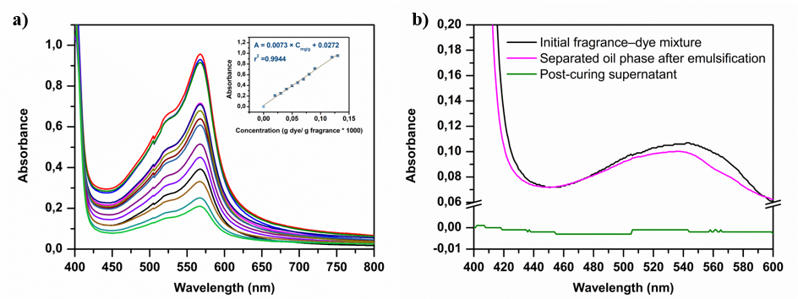
Figure 5. UV-Vis spectrophotometric analysis of the oil-soluble dye used as a tracer in the Green Capsule ENC Last encapsulation study, (a) absorption spectra of the calibration standards (inset as calibration curve), (b) representative absorption spectra of the several stages of the encapsulation reaction.
Finally, the olfactory performance of the fragrance-loaded microcapsules (Pink Capsule ENC Last) was evaluated on fabric samples following laundering. For this purpose, 1.0 g of each formulation was diluted with 99.0 g of the fabric-softener base, and laundering was performed at 30 °C for 17 min. For each encapsulated fragrance formulation, five separate laundering treatments were conducted using two towels per treatment, (i) a control treatment containing the corresponding free fragrance (FF), (ii) a treatment containing the microcapsule dispersion collected before the addition of glycidyl trimethylammonium chloride, without free-fragrance addition (UMC), (iii) functionalized microcapsules with glycidyl trimethylammonium chloride, without free-fragrance addition (CMC), (iv) blend of UMC with free-fragrance(UMC-FB), (v) blend of CMC with free fragrance (CMC-FB). All laundering treatments were performed under identical conditions. The fragrance intensity of the treated towels was evaluated immediately after laundering while the fabrics were still wet, and again after drying and storage for four days with and without rubbing to mimic and evaluate the effect of mechanical stress. All evaluation results were displayed in Table 1
Table 1. Olfactory evaluation score of the tested fabrics.
Treatment | After laundering | After 4 days of drying and storage | After rubbing
Free Fragrance (FF) | 5 | 2 | 2
Unmodified Microcapsules (UMC) | 1 | 1 | 3
Functionalized Microcapsules (CMC) | 1 | 1 | 3.5
Unmodified Microcapsules Blend (UMC-FB) | 3.5 | 3 | 4.5
Functionalized Microcapsules (CMC-FB) | 3.5 | 3 | 5
According to the results, the free fragrance sample (FF) showed the highest olfactory intensity after laundering, as expected, with a radical decrease after storage, and without any significant increase after rubbing because no microcapsules were present in the system. In contrast, both microcapsule-only treatments (UMC and CMC) exhibited low olfactory intensity immediately after laundering and before rubbing, which was attributed to the absence of free fragrance on the fabric. On the other hand, after rubbing, olfactory scores were increased dramatically, indicating that microcapsules had been retained on the textile surface and mechanically ruptured, thereby releasing the encapsulated fragrance. Lastly, both blends (UMC-FB and CMC-FB) provide a satisfactory olfactory intensity both after laundering and storage, with a notable increase after rubbing. When four microcapsule-containing treatments (UMC, CMC, UMC-FB, and CMC-FB) in both cases show that the use of glycidyl trimethylammonium chloride produced slightly higher olfactory scores, suggesting improved capsule deposition or retention on the fabric surface.
- Conclusion
In this work, synthesized fragrance-loaded microcapsules with MMF resin as shell material with in situ polymerization was accomplished, and post-curing functionalization of the capsule shells with glycidyl trimethylammonium chloride was done. Imaging analyses revealed predominantly spherical microcapsules with clearly distinguishable particle boundaries, while TGA results indicated sufficient thermal characteristics. According to the thermogram, post modification caused the plateau observed for the unmodified capsules to shift toward a more gradual, multistage mass-loss profile. Moreover, UV-Vis analysis showed that applied procedure provides a effective encapsulation with a negligible oil residue after curing in the continues phase. Post-curing modification of capsules with glycidyl trimethylammonium chloride not only provided the long-term dispersion stability to the ready-to-use fabric-softener formulation as expected without significant drawbacks but also resulted in slightly improved olfactory evaluation scores, which is attributed to the ionic interaction between cationic capsule with anionic fabric surfaces.
References
Podgornik, B.B, Sandiric, S., & Kert, M. (2021). Microencapsulation for Functional Textile Coatings with Emphasis on Biodegradability - A Systematic Review. Coatings, 11(11), 1371. https://doi.org/10.3390/coatings11111371
Lamboley, S. Vuichoud, B., Saint Laumer JY., & Herrmann, A. (2023). Release of Volatile Cyclopentanone Derivatives from Imidazolidin-4-One Profragrances in a Fabric Softener Application. Molecules, 28(1), 382. https://doi.org/10.3390/molecules28010382
Fei, X., Zhao, H., Zhang, B., Cao, L., Yu, M., Zhou, J., & Yu, L. (2015). Microencapsulation mechanism and size control of fragrance microcapsules with melamine resin shell. Colloids and Surfaces A: Physicochemical and Engineering Aspects, 469, 300-306. https://doi.org/10.1016/j.colsurfa.2015.01.033.
Herrmann, A. (2007). Controlled release of volatiles under mild reaction conditions: from nature to everyday products. Angewandte Chemie (International Edition in English), 46(31), 5836-5863. https://doi.org/10.1002/anie.200700264
Jafari, S.M., Assadpoor, E., He, Y., & Bhandari, B. (2008). Encapsulation Efficiency of Food Flavours and Oils during Spray Drying. Drying. Technology, 26(7), 816-835. https://doi.org/10.1080/07373930802135972
Jamekhorshid, A., Sadrameli, S.M., & Farid, M. (2014). A review of microencapsulation methods of phase change materials (PCMs) as a thermal energy storage (TES) medium. Renewable and Sustainable Energy Reviews, 31, 531-542. https://doi.org/10.1016/j.rser.2013.12.033
Massella, D., Giraud, S., Guan, J., Ferri, A., & Salaün, F. (2019). Textiles for health: a review of textile fabrics treated with chitosan microcapsules. Environmental Chemistry Letters, 17, 1787-1800. https://doi.org/10.1007/s10311-019-00913-w
Murph, D.S. (2015). Fabric Softener Technology: A Review. Journal of Surfactants and Detergents, 18(2), 199-371. https://doi.org/10.1007%2Fs11743-014-1658-2
Pithanthanakul, U., Vatanyoopaisarn, S., Thumthanaruk, B., Puttanlek, C., Uttapap, D.,Kietthanakorn, B., & Rungsardthong V. (2021). Encapsulation of fragrances in zein nanoparticles and use asfabric softener for textile application. Flavour and Fragrance Journal, 3(36), 319-432. https://doi.org/10.1002%2Fffj.3648
Su, JF. Wang, WY, & Dong, H. (2012). Influence of temperature on the deformation behaviors of melamine-formaldehyde microcapsules containing phase change material. Materials Letters, 84, 158-161. https://doi.org/10.1016/j.matlet.2012.06.074
Su, JF., Wang, LX., & Ren L. (2004). Preparation and Characterization of Double-MF ShellMicroPCMs Used in Building Materials. Journal of Applied Polymer Science, 5(97), 1755-2174. https://doi.org/10.1002%2Fapp.21205
Sumiga, B., Knez, E., Vrtacnik, M., Ferk Savec, V., Staresinic, M., & Boh, B. (2011). Production of Melamine-Formaldehyde PCM Microcapsules with Ammonia Scavenger used for Residual Formaldehyde Reduction. Acta chimica Slovenica, 58(1), 14-25. PMID: 24061938.
Topbas, O. Sariisil, A.M., Erkan G., & Ek. O. (2020). Photochromic Microcapsules by Coacervation and In Situ Polymerization Methods for Product-Marking Applications. Iranian Polymer Journal, 29, 117-132. https://doi.org/10.1007/s13726-019-00781-9
Yu, C., Hu, J., Chen, Y., Yang, Q., Zhang, Y., Wang, C., & Chen, K. (2021). Rapid synthesis of strawberry microcapsules via Pickering emulsion photopolymerization for use in multifunctional fabric coatings. Progress in Organic Coatings, 152, 106110. https://doi.org/10.1016/j.porgcoat.2020.106110
Yun, P., Devahastin, S.,& Chiewchan, N. (2021). Microstructures of encapsulates and their relations withencapsulation efficiency and controlled release of bioactiveconstituents: A review. Comprehensive Reviews in Food Science and Food Safety, 20(2), 1119-2262. https://doi.org/10.1111%2F1541-4337.12701
Zaitoon, A. Luo X., & Lim LT. (2021). Triggered and controlled release of active gaseous/volatile compounds for active packaging applications of agri-food products: A review. Comprehensive Reviews in Food Science and Food Safety, 1(21), 541-579. https://doi.org/10.1111/1541-4337.12874

DECLARATIONS
SECTION | STATEMENT / DISCLOSURE
Author Contributions | Bleda Can Sadikogullari: Conceptualization, Data curation, Formal analysis, Investigation, Methodology, Writing - original draft. Harun Taşdemir: Data curation, Formal analysis, Methodology, Writing - original draft. Özge Kavaş: Data curation, Formal analysis, Methodology, Writing - original draft. Yeşim Cat: Data curation, Formal analysis, Methodology. Akın Sağırlı: Investigation, Validation, Writing - review and editing. Sonay Gürer: Conceptualization, Formal analysis, Investigation, Methodology, Supervision, Validation. Bunyamin Karagoz: Conceptualization, Data curation, Formal analysis, Investigation, Methodology, Supervision, Validation, Writing - original draft, Writing - review and editing. All authors have read and agreed to the published version of the manuscript.
Conflict of Interest | The authors declare that they have no known competing financial interests or personal relationships that could have appeared to influence the work reported in this paper.
Funding | This study was financially supported by Parkim Parfüm Plastik ve Kimya Ltd. Şti.
Declaration of Generative AI | During the preparation of this work, a generative AI tool was used to improve the grammar, clarity, and terminological consistency of English texts written by the authors. The generative AI tool did not generate any experimental data, design experiments, or independently produce scientific conclusions. All experimental data, calculations, interpretations, and scientific conclusions presented in this work were reviewed, verified, and approved in their final form by the authors.
Ethics Approval | No ethical approval is required for this study.
Acknowledgements | The authors would like to than to the Central Research Laboratory Application and Research Center (ARUM) of Eskişehir Osmangazi University for providing the SEM facilities, the Central Research Laboratory Application and Research Center (GTÜMAR) of Gebze Technical University for providing the TGA facilities, and Istanbul Technical University for providing the facilities required to carry out the experimental studies.

